**prep week computer basics computer structure and functions Maria Dahmosh**

1. What is binary code, and why is it important in computing?

* Binary code is the most basic form of computer code, consisting of two numbers: 0 and 1. These numbers form the basic layer of all computing systems and are the primary language of digital technologies. Binary code uses combinations of these two numbers to represent numbers, letters, or other types of information.
* Binary plays a critical role in computing because it allows computers to store and manipulate data using a system of switches that can be turned on or off, represented by the digits 0 and 1 .

1. How many digits are there in the binary number system, and what are they?

Binary numbers are represented by only two symbols or digits, i.e. 0 (zero) and 1(one). Each digit in this system is said to be a bit.

1. Explain what a bit and a byte are in computing.

* Bit is the smallest unit of the computer. It is usually represented with digits 0 and 1.
* Byte is made of 8 bits. It is used in determining the system storage. Byte is the most common term used in computing.

1. What is the role of transistors in computer circuits?

Transistors are the main component of the microchips used in computers. Computers operate on a binary system, which uses only two digits: 0 and 1. In a computer microchip, transistors act as switches, letting current through to represent the binary digit 1, or cutting it off to represent 0.

1. Describe the function of the Central Processing Unit (CPU) in a Computer

The CPU is the brain of a computer, containing all the circuitry needed to process input, store data, and output results. The CPU is constantly following instructions of computer programs that tell it which data to process and how to process it.

1. What is the difference between RAM and ROM in computer memory?

|  | **RAM** | **ROM** |
| --- | --- | --- |
| **Definition** | Random Access Memory or RAM is a form of data storage that can be accessed randomly at any time, in any order and from any physical location., allowing quick access and manipulation. | Read-only memory or ROM is also a form of data storage that can not be easily altered or reprogrammed.Stores instuctions that are not nescesary for re-booting up to make the computer operate when it is switched off.They are hardwired. |
| **Stands for** | Random Access Memory | Read-only memory |
| **Use** | RAM allows the computer to read [data](https://www.diffen.com/difference/Data_vs_Information) quickly to run applications. It allows reading and writing. | ROM stores the program required to initially boot the computer. It only allows reading. |
| **Volatility** | RAM is volatile i.e. its contents are lost when the device is powered off. | It is non-volatile i.e. its contents are retained even when the device is powered off. |
| **Types** | The two main types of RAM are static RAM and dynamic RAM. | The types of ROM include PROM, EPROM and EEPROM. |

1. Explain the concept of a logic gate and provide an example.

We send information through computers using wires that represent 1s and 0s. Computers need a way to manipulate those 1s and 0s and computers use logic gates to transform the 1s and 0s from input wires. A logic gate accepts inputs and then outputs a result based on their state.

NOT gate

The simplest gate is the NOT gate, also known as an inverter. It accepts a single input and outputs the opposite value.

If the input is  0 the output is  1:



1. How do logic gates like AND, OR, and NOT contribute to computing?

The combination of these gates create logic circuits that will allow a specific function to be carried out.

 They are used to control the flow of information, create complex circuits, and understand how computers work at a fundamental level. Without logic gates, modern digital electronics and computer programming as we know it would not be possible.

1. Describe the binary representation of numbers in a computer.

binary numbers are represented by only two symbols or digits, i.e. 0 (zero) and 1(one). The binary numbers here are expressed in the base-2 numeral system.

1. What is ASCII, and how does it relate to character encoding in computing?

* ASCII (American Standard Code for Information Interchange) is the most common character encoding format for text data in computers and on the internet. In standard ASCII-encoded data, there are unique values for 128 alphabetic, numeric or special additional characters and control codes.
* It assigns a unique number to each character used in most of the Western world, like letters, digits, punctuation marks, and control characters. This numerical representation allows computers to understand and manipulate text. ASCII uses a 7-bit binary number, which gives it a total of 128 possible characters.

1. Explain how a CPU processes instructions using the fetchdecode-execute cycle.

* The CPU (Central Processing Unit) processes instructions through a sequence of steps known as the "instruction cycle" or "fetch-decode-execute cycle." This cycle is fundamental to the operation of a CPU and is repeated for each instruction it needs to execute.
* The Fetch Decode Execute Cycle is a process used by a computer's central processing unit (CPU) to run instructions. Each cycle retrieves an instruction from memory (fetch), translates it into a series of commands (decode), and then performs the required action (execute).

1. What is a motherboard, and what role does it play in a computer's architecture?

A motherboard is the main circuit board in a computer system. It connects all of the internal components, like the memory, processor, graphics card and other hardware. It also provides power to each component and allows them to communicate with each other.

1. Describe the concept of a CPU cache and its importance in computer performance.

A CPU cache is a small, fast memory area built into a CPU (Central Processing Unit) or located on the processor's die. The CPU cache stores frequently used data and instructions from the main memory to reduce the number of times the CPU has to access the main memory for this information. This can greatly improve system performance, as accessing data from the CPU cache is much faster than accessing data from the main memory.

1. How does a hard drive store data magnetically, and what are sectors and clusters?

The hard drive contains a spinning platter with a thin magnetic coating. A "head" moves over the platter, writing 0's and 1's as tiny areas of magnetic North or South on the platter. To read the data back, the head goes to the same spot, notices the North and South spots flying by, and so deduces the stored 0's and 1's.

Hard disks have many circular pieces called platters inside them. These platters have two sides are made up of tracks, sectors, and clusters. A cluster is a group of sectors, and a sector divides tracks into pie shaped sections.

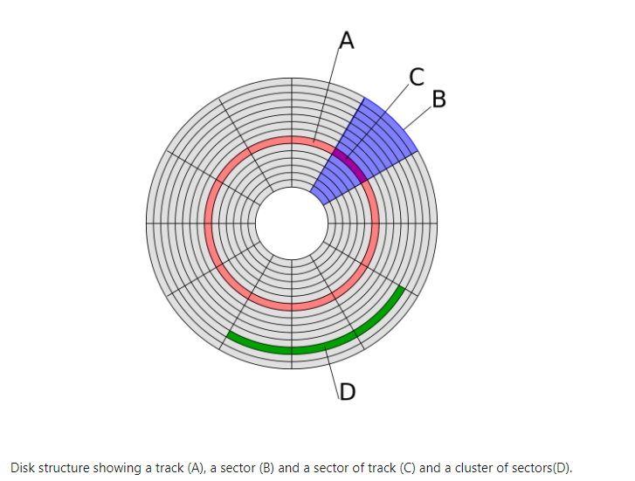

1. What is Moore's Law, and how has it influenced the development of computer hardware?

Moore's Law states that the number of transistors on a microchip doubles about every two years with a minimal cost increase.

The number of transistors doubling then roughly equates to more computing power, memory, etc.